
Pastor's October Message

OCTOBER 2024

MESSENGER
a monthly publication
of
First Congregational
United Church of Christ
121 First Avenue SE
Watertown,
South Dakota 57201

Mail: P.O. BOX 111
Website: https://www.uccwatertown.com
E-Mail: ucc1wtn@midco.net
Phone: (605)886-6994
Office: 8:00-12:00, M-F
Sunday Worship - 10:00 a.m.
Church School 9:15 am

Facebook Search: @firstcongregationalwatertown

Minister:
Pastor Dustin Bartlett
Moderator: Susan Aamold
Treasurer & Financial Secretary:
Brenda Zemlicka
Music Director:
Bruce Reinhardt
Secretary:
Virginia McDaniel
Youth Director:
Rachel Clendenin
Custodian:
Scott Anderson

Siblings in Christ,

As I write this, it’s the second day of the fall season. In the natural world, fall is a time when things slow down. The leaves slow their photosynthesis and turn red or yellow before dropping off entirely. Animals prepare their dens to snuggle in for the winter.

But at First Congregational Church, we’re not slowing down.

This month, our church is going to be serving the Banquet – a free meal available to anyone who wants it. The Banquet happens at Grace Lutheran Church, but it will be our church that buys and prepares and serves the food. That’s happening on October 14th, and volunteer signup sheets are in the back of the sanctuary.

Our church is also taking care of delivery for Meals on Wheels during the last week of October, from 10/28 – 11/1. Our volunteers deliver meals prepared by the local senior center to senior citizens throughout the community. If you’d like to help with Meals on Wheels, please speak to Lynne Forbush.

A few church members are also working on organizing a multicultural banquet with the intention of helping foster understanding, communication, and community across ethnic and national boundaries. I’ll let you know more about that as it takes shape.

Finally, we continue to collect donations of personal hygiene products for Rachel’s Hope and donations of food for the Salvation Army.

One thing that I love about this church – we might not be the biggest church in town, but we sure do get a lot done!

Blessings,

Rev. Dustin Bartlett

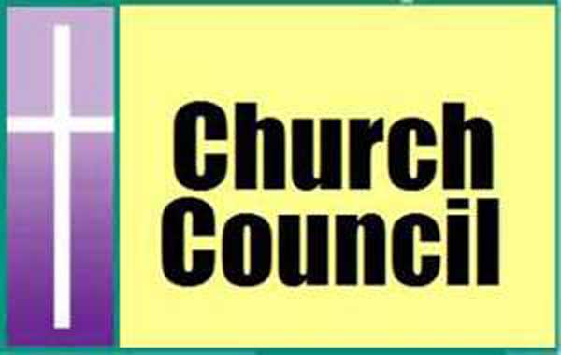
Moderators October Message
Church council meeting, Monday, October 21, 2024 6pm
(The council meeting has been changed to the above date)

Hello!

Welcome to fall! The mornings are cool and the leaves are falling!
The church council continues to work on several projects within our church; some are for the church building and some are for the community.
I am happy to report that the door on the west side of the building is being replaced as I am writing this! I know it has taken some time but I think we will all be happy with the results.
You have been hearing about the sidewalk replacement for months now, I know. Turns out we needed a sidewalk replacement permit prior to actually replacing our sidewalk. The good news is that the permit process has been completed and we are now ready for the contractor to get started.

You have been hearing a lot about Rachel’s Hope. This program continues to build momentum. Thank you to everyone who has donated hygiene products or has made financial donations. You are truly making a difference. Stay tuned for more updates and developments on how you can become a volunteer for Rachel’s hope.

We have two really amazing WinGs meetings this month. The WinGs group is such a special group with a strong focus on how we can go out, do things for our community and bring our community together.
We are going to be serving the banquet at Grace Lutheran Church on Oct. 14 (please see sign up sheets in the narthex). There are several ways in which you can participate and be a part of this event. We will also be selling homemade crafts at the “Got it At Grace” Grace Lutheran Craft Fair on November 2. Be sure to check out this event and stop by our table. Just look for the table with the First Congregational UCC banner!

Last thing I want to mention is Universal Church Directories will be at our church to take photographs for our church directory on Nov 12 and 13. One thing to note; the photographs will be back to you the first week of December so just in time for Christmas cards. More information is coming soon!
Love to all, Susan

HOME BOUND FRIENDS (up dated)

Last First Address Phone
Anderson Waneta 215 S Maple #339 605-753-3275 Jenkins
Bevers Jean 500 16th Ave NE # 26 605-886-6519 StoneyBrook
Friese Garrold 215 S. Maple #342 Jenkins
Gribble Ramona 6 1st St. SW # 504 605-881-0006
Jordan Diane 3800 20th Ave. SW 605-886-2885
Krull Phyllis 215 S.Maple #316 Jenkins
Pope Donna 215 S. Maple #288 605-361-1422 Jenkins
Richardson Nell 614 N. Broadway 605-886-4041
Ruesink Joyce 901 14th Ave.NE 605-520-3670 Edgewood
Tate Jan 215 S. Maple # 431 Jenkins
Zemlicka Wilma 46156 160th St. 605-882-2004

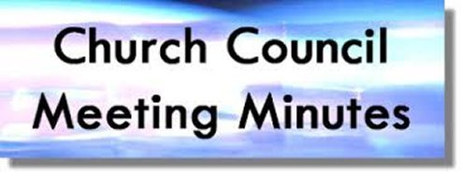
Church Council Minutes
September 9th, 2024
Attendants: Susan Aamold, Jerica Gilbertson, Brenda Zemlicka, Pastor Dustin Bartlett, Rosanne Dyce-Anderson, Cyndy Voight, Robin Briggs,
Shari Wirkus, Jordan Zemlicka, Sue Pearson, Melissa Pond
Absent: Wayne Johnson
- Call to Order – Susan Aamold
- Opening Prayer – Pastor Dustin Bartlett
- Approval of August Minutes – Motion by Sue Pearson to approve August minutes. Second by Rosanne Dyce-Anderson. Approved.
- Reports:
  - Treasurer – The five month CD that was set up in April matured, it is now in the Memorial Fund checking account. Previously we decided to take $20,000 out of the United Church fund every other month, three times, so that will happen this month. There are two weddings at the church in October, their down payments are in the account. There are currently two forms for reports that are repetitive, we are going to change it to one. Rosanne Dyce-Anderson made a motion to approve the treasurer’s report. Seconded by Cyndy Voight. Approved.
  - Pastor –
    - The Sunday School Kickoff went well, regular Sunday School classes start September 15th
    - We are going to drop adult confirmation, as it was just not well attended
  - Worship Committee – All Saints Day is November 1st
  - Mission & Outreach Committee – next WINGS meeting is September 21st at 9 AM
- Old Business:
  - Building and Grounds strategy/plan update:
    - Internet - Rosanne Dyce-Anderson made a motion to approve the quote from Connecting Point for the business wifi. Seconded by Melissa Pond. Approved.
    - Sidewalk - being done sometime in September
    - West Door - This door was accidentally put onto a different church. They will come back and put it on our church.
    - Roof - there was a construction company that came to fix falling roof
    - Email - We need to upgrade to a business class email, so that we cannot be hacked. This costs $150 for each email (there are 2), and a one time charge of $600 to start. Sue Pearson made a motion to get the business class email. Seconded by Cyndy Voight. Approved.
  - Universal Church Directory - Dates set for November 12-13, still waiting on materials
  - Rachel’s Hope - continuing donation drive, donations of things, also take cash or check, just note it in the memo at offering time. They are having a meeting in January, they want to plan an event/fundraiser for people to see what it is.
  - Working on another 1946 showing - this is not going to happen, you can now stream it on Amazon Prime
  - September 29th - Pastor Dustin will be gone, Lucas is going to do the service
- New Business:
- Video Streaming proposal - There is a quote from Midstates Audio for $19,000, or another option is to buy a gaming computer to solve the issue of streaming. Sue Pearson made a motion to buy a new computer and potential software up to $4,000 to try to fix the problem. Jordan Zemlicka seconded. Approved.
- Money Counter Sign Up
- Next Meeting Date – Monday, October 7th at 6
- Executive Session – A motion was made by Melissa Pond to go into executive session. Second by Sue Pearson. Approved.
- Adjournment – A motion was made by Sue Pearson to adjourn the meeting. Second by Jordan Zemlicka. Approved.

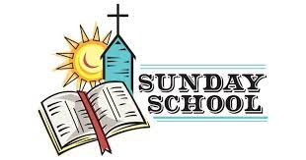
Christian Youth October Report
“I’m so glad I live in world where there are Octobers.”
-L.M. Montgomery, Ann of Green Gables
October colors our world right now. It is a beautiful time of year before the long haul of winter. Much like October, I am so glad I live in a world where there are kiddos. They add color and brightness to the world.
In Christian Education, we celebrated our Sunday School Kick-off. The kiddos enjoyed a bouncy house, a balloon man, and a potluck picnic. (The yellow jackets also enjoyed the picnic!) It is always a joy to see the kids having fun.
We’ve studied following Jesus by making paint tracks, listening to God like Jonah in the big fish, and caring for one another. After the first month it promises to be an exciting, energetic, and enthusiastic year!
Please Note:
No Church School on October 6 ~ – Rachel is out of town for a conference
May your October be bright and joyous like our kiddos!

Blessings ~ Rachel Clendenin



Mark your calendars, the Universal Church Directories will be at our church to take photographs for our church directory on Nov 12 and 13. The photographs will be back to you the first week of December, so if you want to have them for your Christmas cards there will be plenty of time.
Schedule your appointment early.

First Congregational United Church of Christ Non-Profit Org.
PO Box 111 U.S. Postage Paid
Watertown, SD 57201 Watertown, SD
THE MESSENGER, October 2024 Permit # 499
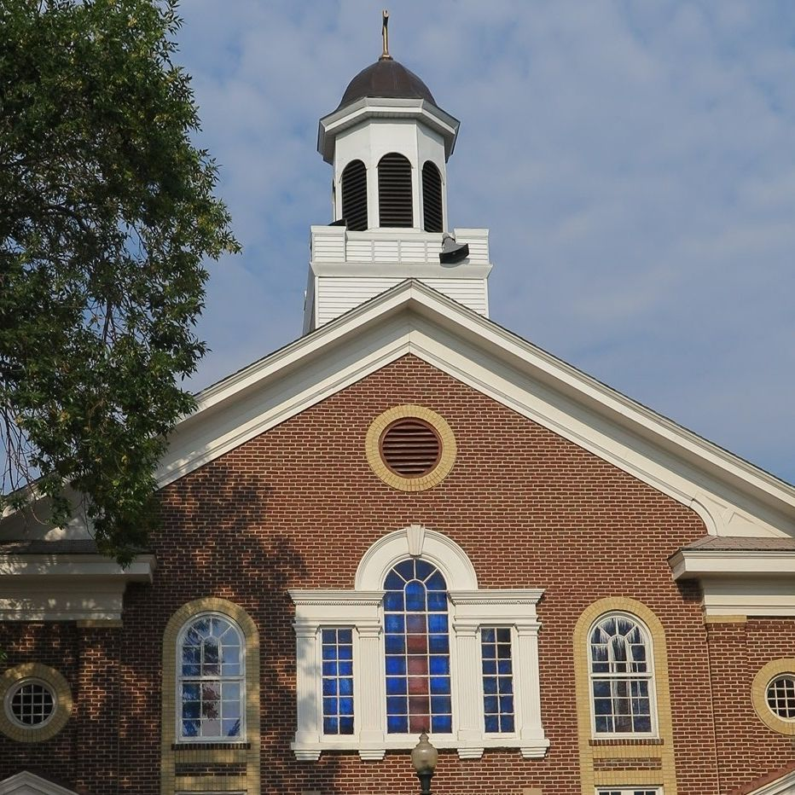

Come Worship with
Pastor Dustin Bartlett
10:00 am Sunday
Everyone is always welcome
If you can not make it to the Sunday service, you
can follow us at; http://www.uccwatertown.com.

Prairie Lakes Association Fall Meeting
October 13, 2024, Ipswich SD UCC
Registration 2:30pm
Worship Service 3:00 pm

Full meal to follow business meeting, No cost for the meal.
605-216-3025


Sunday morning coffee, everyone is always welcome
to join us in the fellowship hall following the church service for coffee and pastries.

