
Pastor's December Message

DECEMBER 2024

MESSENGER
a monthly publication
of
First Congregational
United Church of Christ
121 First Avenue SE
Watertown,
South Dakota 57201

Mail: P.O. BOX 111
Website: https://www.uccwatertown.com
E-Mail: ucc1wtn@midco.net
Phone: (605)886-6994
Office: 8:00-12:00, M-F
Sunday Worship - 10:00 a.m.
Church School 9:15 am

Facebook Search: @firstcongregationalwatertown

Minister:
Pastor Dustin Bartlett
Moderator: Susan Aamold
Treasurer & Financial Secretary:
Brenda Zemlicka
Music Director:
Bruce Reinhardt
Secretary:
Virginia McDaniel
Youth Director:
Rachel Clendenin
Custodian:
Scott Anderson

Siblings in Christ,

Here at First Congregational Church, it’s beginning to look a lot like Christmas. The tree is up. The nativity scene is on display on our altar. But it’s not Christmas until December 25th. Before that comes Advent.

Advent is a season of preparation, of longing, and of waiting. We look forward to the birth of Christ and prepare our hearts to receive him – on Christmas, especially, but also every day as we try to walk in his footsteps by extending love to the last, the least, and the lost. We light the candles of the advent wreath to remember the gifts that Christ brings – hope, peace, joy, and love.

Our Christmas pageant will be on December 22nd, the Sunday before Christmas, so please come to worship and encourage our young people as they share their interpretation of the birth of Jesus.

Our Christmas Eve service will be a service of lessons & carols at 5:30 pm on December 24th.

During the holiday season, there will no doubt be lots of shopping for Christmas gifts, but there are also opportunities for you to give to those in need. We will have the Christmas tree with gifts for low-income families again this year, so please take a tag and buy a gift for someone in need. And, in addition to our usual ongoing collection of food for the Salvation Army and hygiene products for Rachel’s Hope, this year Rachel’s Hope is offering a way to sponsor a family for the month of December for only $50. You can make a check out to Rachel’s Hope or put cash in an envelope and mark it for Rachel’s Hope and we’ll see that they get it.

May you all have a blessed Advent filled with hope, peace, joy, and love.

Blessings,

Rev. Dustin Bartlett


Moderators December Message
Hello,
I hope everyone had a wonderful Thanksgiving! Thanksgiving is a great time to
get together with family and friends and of course the opportunity to eat great food!
It is also a time to express gratitude for all the wonderful gifts we have received throughout the year.
One of the wonderful gifts I received this year was the opportunity to serve as Moderator for the UCC and this amazing UCC family. We accomplished so much this year and with each project we took on, there came learning experiences as well that I will always be grateful for.
The latest project we have taken on being the photography sessions for the upcoming directory. I know that it was not easy to take time during the week, coordinate several family members in some cases and prepare for the actual photography session. We had 46 signups! I want to sincerely thank everyone who participated in this project. I am now working on pulling all the other pieces together needed to complete the directory. Don’t be surprised if I reach out to each of you asking for pictures, stories, etc. We will also be working to confirm all active members in order to have a complete and updated membership list in 2025. This process does take time so while you should be receiving your individual photographs early December, the directories will most likely not be ready until late spring. Trust me, the directories will be worth the wait!

Happy Holidays!

Susan

HOME BOUND FRIENDS (up dated)
Last First Address Phone
Anderson Waneta 215 S Maple #339 605-753-3275 Jenkins
Bevers Jean 500 16th Ave # 26 605-886-6519 StoneyBrook
Friese Garrold 215 S. Maple #342 Jenkins
Gribble Ramona 6 1st St. SW # 504 605-881-0006
Jordan Diane 3800 20th Ave. SW 605-886-2885
Krull Phyllis 215 S.Maple #316 Jenkins
Pope Donna 215 S. Maple #288 605-361-1422 Jenkins
Richardson Nell 614 N. Broadway 605-886-4041
Ruesink Joyce 901 14th Ave.NE 605-520-3670 Edgewood
Tate Jan 215 S. Maple # 431 Jenkins
Zemlicka Wilma 46156 160th St. 605-882-2004

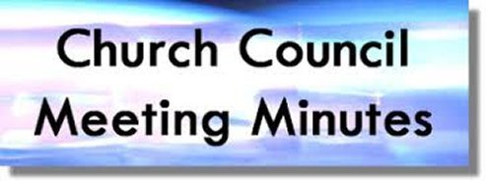
Church Council Minutes
November 18th, 2024
Attendants: Susan Aamold, Jerica Gilbertson, Brenda Zemlicka, Pastor Dustin Bartlett, Rosanne Dyce-Anderson, Wayne Johnson, Robin Briggs, Shari Wirkus, Jordan Zemlicka, Sue Pearson, Melissa Pond
Absent: Cyndy Voight
- Call to Order – Susan Aamold
- Opening Prayer – Pastor Dustin Bartlett
- Approval of October Minutes – Motion by Sue Pearson to approve August minutes. Second by Rosanne Dyce-Anderson. Approved.
- Reports:
  - Treasurer – There was a check designated for Rachel’s Hope, which was sent to them. Scott was paid extra for the weddings he helped with. There was some money spent on a new computer for Dustin and the conference he attended. The bills for the sidewalk, piece hanging off church, Connecting Point, and Glass Products were all paid. November was supposed to be the next month to take $20,000 out of the United Church fund to use. Jerica Gilbertson made a motion to not take $20,000 out of the United Church fund and re-evaluate if we need it next month. Seconded by Rosanne Dyce-Anderson. Approved.
Sue Pearson made a motion to approve the treasurer’s report. Seconded by Melissa Pond. Approved.
  - Pastor –
    - There will be a Zoom meeting December 2nd to vote on calling Rev. Roberto Ochoa to be the new conference minister. Anyone can attend this meeting, but we only have a certain amount of votes.
  - Welcoming Committee – Lists of members/friends were compared. If you are not getting the Wednesday message and should be, let Pastor Dustin know.
  - Personnel Committee – Did not have a meeting this month, because it fell on Election Day which was a holiday.
  - Building & Grounds Committee – No more projects this year. Scott went and got dirt from Rodney & Brenda Zemlicka’s and filled it beside the sidewalk. Thank you so much Scott!
- Old Business:
  - Universal Church Directory - There were 46 seatings, they went well. Pictures will be sent out soon, but directories will take a little while. If you missed it and want to be in the directory, make sure to talk to Susan.
  - Rachel’s Hope - We will run another donation list.
  - Business solutions - Connecting Point - Sue Pearson made an email to spend $1,200 on new business emails. Jerica Gilbertson seconded. Approved.
  - International Food Fair - this will not be on December 7th, as it is going to be tabled indefinitely. There is currently no ESL at the multicultural center being offered. If you know of anyone that can help, please talk to Susan.
- New Business:
- Annual Meeting Reports - We will have a potluck for Annual Meeting, which will tentatively be on January 19th.
- Nominations for Church council members - we will have 3 spots for council and the moderator position open. Please talk to a member of the nominating committee (Lynne Forbush, Dawn Engel, & Julie Johnson) if you are interested.
- Sunday School Christmas program date - Trying to figure out a date for the Christmas pageant.
- Financial assistance for individuals in need - try to direct them to places that can help them
- 2025 budget - will start working on soon
- Money Counter Sign Up
- Next Meeting Date – Monday, December 9th at 6 PM

- Executive Session – A motion was made by Rosanne Dyce-Anderson to go into executive session. Second by Melissa Pond. Approved.
- Adjournment – A motion was made by Sue Pearson to adjourn the meeting. Second by Jerica Gilbertson. Approved.
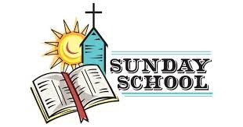

December Christian Ed Report
Things have been staying pretty busy in the Christian head department. We've had between 10 to 12 kids for the last few weeks so our attendance has been good. We have some new faces which is exciting. We've predominantly been following the lectionary, but did a few Old Testament favorites with the kiddos.
Respectfully submitted,
Rachel Clendenin
Sunday, December 22, 2024 during the worship service, the youth will be presenting their annual
Christmas program. Please make an effort to join us for worship on that Sunday and every Sunday.
Thank you Rachel Clendenin for putting this together.


A big thank you to the following who delivered Meals on Wheels the week of Oct. 28 - November 1: Glen Robel, Ken & Wendy Fransen, Don & Jan Goldhorn, Jo Gardner & Curt Kost, Dan & Cyndy Voight, Sue & Alan Pearson, Rosanne Dyce-Anderson & Rose Moehring, Frank Kitterman, and Mitzi Heath & Cheri Larson. In addition to meals this group also delivered Thanksgiving cards that many of you signed. This is the last time our church will deliver meals this year and will next be responsible in early January 2025. I would like to recognize Don & Marlys Moore for the many years they have delivered Meals on Wheels. They have decided to retire and now deserve a heartfelt round of applause and our thanks. Lynne Forbush



Just a note that if you have a gift to put under the Angel Christmas tree the gifts usually need to be under the tree at least a week before Christmas so they will be distrubited to everyone in time for Christmas.

First Congregational United Church of Christ Non-Profit Org.
PO Box 111 U.S. Postage Paid
Watertown, SD 57201 Watertown, SD
THE MESSENGER, December 2024 Permit # 499
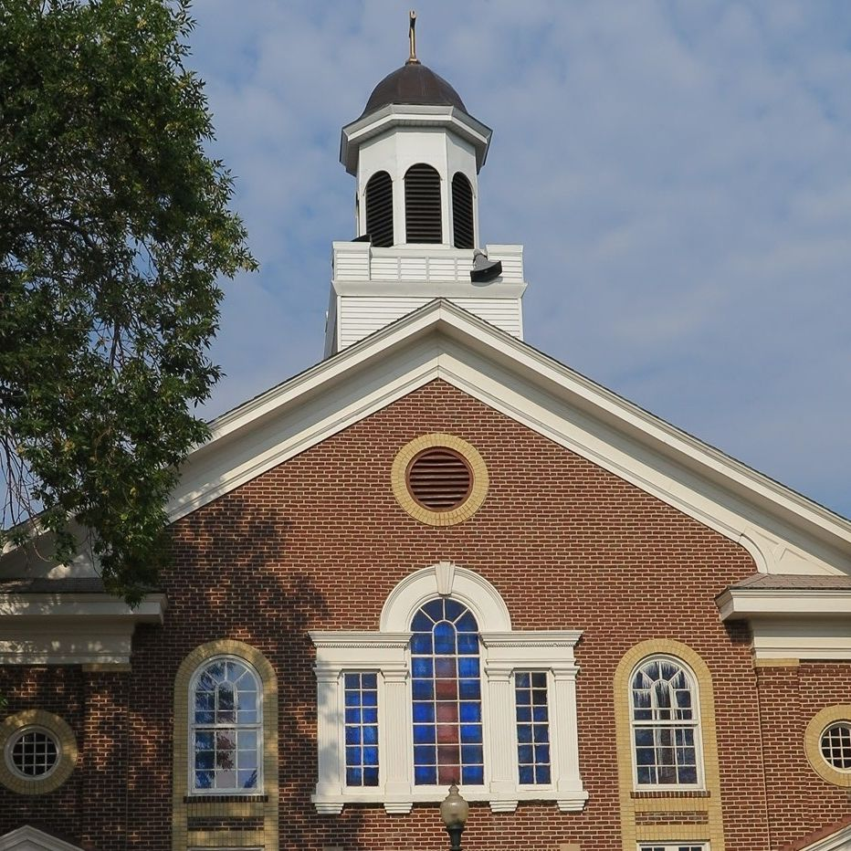

Come Worship with
Pastor Dustin Bartlett
10:00 am Sunday
Everyone is always welcome
If you can not make it to the Sunday service, you
can follow us at; http://www.uccwatertown.com.


.



Sunday morning coffee, everyone is always welcome
to join us in the fellowship hall following the church service for coffee and pastries.

Coffee upstairs before and downstairs after Sunday morning worship
Sunday, Dec. 22, during the worship service is the Youth Christmas Program
Tuesday, Dec. 24, 5:30 pm Candle light service
The Angel tree is decorated with tags, be sure your gift is under the tree at least a week before Christmas.
 | DECEMBER 2024
Sun | Mon | Tue | Wed | Thu | Fri | Sat
1  Communion Sunday | 2 | 3 | 4 | 5  Shari Wirkus  Theresa Igo | 6 | 7
8  Bible Study 3PM | 9  Church council 6pm | 10 | 11  Bill Shepherd | 12 | 13  Julia Erichsen  Julian Rambow | 14  Trevor Matteson  WinG’s Christmas Meeting 10am All are welcome
15 | 16 | 17 | 18 | 19  Rebekah Brasel | 20 | 21
22  Kathy Gaede  Grace Bartlett  Christmas Youth  Program  Bible Study 3PM | 23 | 24  Dustin Bartlett  5:30 pm Christmas Eve service (candlelight service | 25  Merry Christmas | 26  Frank Kitterman | 27 | 28  Ramona Gribble
29  Kathy Robel  Bev Bartlett | 30 | 31  Ethan Zemlicka | W.I.N.G.S. will have a Christmas get together on Saturday December 14th at 10:00. All women are welcome! Bring a dozen of your favorite Holiday treats to share with coffee! We also will be discussing our plans for next year.. Mark your calendars and plan to come!

