
Pastor's January Message

JANUARY 2025

MESSENGER
a monthly publication
of
First Congregational
United Church of Christ
121 First Avenue SE
Watertown,
South Dakota 57201

Mail: P.O. BOX 111
Website: https://www.uccwatertown.com
E-Mail: ucc1wtn@midco.net
Phone: (605)886-6994
Office: 8:00-12:00, M-F
Sunday Worship - 10:00 a.m.
Church School 9:15 am

Facebook Search: @firstcongregationalwatertown

Minister:
Pastor Dustin Bartlett
Moderator: Susan Aamold
Treasurer & Financial Secretary:
Brenda Zemlicka
Music Director:
Bruce Reinhardt
Secretary:
Virginia McDaniel
Youth Director:
Rachel Clendenin
Custodian:
Scott Anderson

Sisters and Brothers,

Merry Christmas, and Happy New Year!

The month of January means that our church will be holding its annual meeting this month to vote on new members of the church council, to approve a budget, to receive reports, and to review 2024 as we begin to reflect on 2025.

The annual meeting is tentatively scheduled for January 19th (assuming no South Dakota winter surprises).

If you are a person or part of a committee that needs to include a report in the annual meeting booklet, please start working on that in order to get it to Ginny as soon as possible. The annual meeting booklet takes days to assemble.

Also, I wanted to say thank you to everyone who sent birthday cards, Christmas cards, and gifts. I truly appreciate the love and support of this church.

Blessings,
Rev. Dustin Bartlett

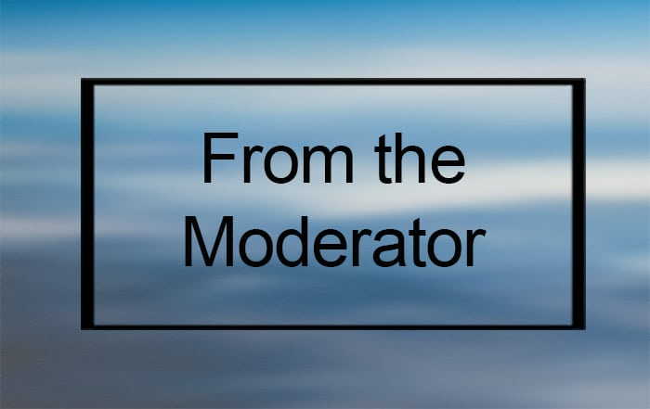

Moderators January Message
Hello and Happy Holidays!
It is hard to believe 2024 will be drawing to a close next week! What a year 2024 was!
The UCC saw many accomplishments this year; some of those accomplishments were much needed improvements to the actual physical building like the sidewalk, west door, etc and some accomplishments were to help the community; suicide awareness workshop and hosting an LGBTQ presentation at our church.
We as a church should be very proud of these achievements as we ALL had a part in them. As your moderator this past year, I want to thank the UCC congregation and council for the support in getting these accomplishments started, carried through and completed. It has been an amazing year and I am very much looking forward to 2025!
See you all at the annual meeting on January 19 and have a very Happy New Year! ~ Susan

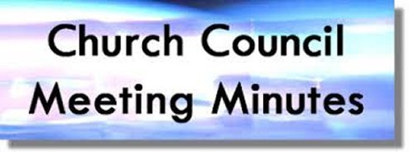
Church Council Minutes
December 9th, 2024

Attendants: Susan Aamold, Jerica Gilbertson, Brenda Zemlicka,
Pastor Dustin Bartlett, Rosanne Dyce-Anderson, Wayne Johnson, Robin Briggs, Shari Wirkus, Jordan Zemlicka, Sue Pearson, Melissa Pond, Shawn Pugsley
Absent: Cyndy Voight
- Call to Order – Susan Aamold
- Opening Prayer – Pastor Dustin Bartlett
- Approval of November Minutes – Motion by Sue Pearson to approve November minutes. Second by Shari Wirkus. Approved.
- Reports:
  - Treasurer – There was a wedding deposit refund for $150 and food for the banquet that was not donated cost $107.03. We made it an extra month without taking anything out of the United Church fund, but now we need to take more out. Rosanne Dyce-Anderson made a motion to take $20,000 out of the United Church fund. Seconded by Jerica Gilbertson. Approved. Robin Briggs made a motion to approve the treasurer’s report. Seconded by Sue Pearson. Approved.
  - Pastor –
    - There will be year-end performance reviews for staff
    - Pastor Dustin will be gone on December 29th, we will do a hymn sing along service.
    - Rev. Roberto Ochoa was voted in to be the next conference minister
- Executive Session – A motion was made by Rosanne Dyce-Anderson to go into executive session. Second by Wayne Peterson. Approved.
  - Worship Committee – We will use candles for Christmas Eve
  - Personnel Committee – working on doing year end evaluations
  - Building & Grounds Committee – There will be a print out to go through at the annual meeting of what has happened and what we will work on next year
  - Mission & Outreach Committee – there will be a special offering on December 22nd
- Old Business:
  - Universal Church Directory - There were actually 44 seatings, we are working on finalizing the list
  - Business solutions - Connecting Point - The motion made at the last meeting was not enough money. Sue Pearson made a motion to increase the motion to $1450.69 to match the Connecting Point quote for 3 emails. Rosanne Dyce-Anderson seconded. Approved.
  - Annual Meeting Reports - tentatively January 19th, get your reports in
  - 2025 Budget
  - 2025 Nominations for Church council members - working on nominations, if you are interested reach out to someone on the nominating committee (Lynne Forbush, Dawn Engel, & Julie Johnson) Jerica Gilbertson will be the clerk for the annual meeting.
  - Sunday School Christmas program date - 12/22
- New Business:
- Gifts for staff - gift cards - Melissa Pond made a motion to do $50 cash for staff, $100 for Pastor Dustin. Seconded for Sue Pearson. Approved.
- Pulpit supply for 12/29 - carols
- Money Counter Sign Up

- Next Meeting Date – Annual Meeting January 19th after church (potluck)
- Executive Session – A motion was made by Jerica Gilbertson to go into executive session. Second by Rosanne Dyce-Anderson. Approved.
A motion was made by Sue Pearson to approve the proposed budget of $220,582.10 to be presented at the annual meeting. Seconded by Shari Wirkus. Approved.

- Adjournment – A motion was made by Rosanne Dyce-Anderson to adjourn the meeting. Second by Sue Pearson. Approved.

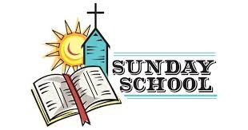

January Christian Ed Report

May God show the blessings you seek in 2025! It’s a new year! One of my blessings has been working with the kiddos and the wonderful people of this Church. From hugs from 3-year-olds and hi-fives from 8th graders to offers of support from church members, I am blessed
beyond words.
In the education wing, we’ve been busy with the Christmas program! It was so much fun to have all the kiddos share in some ministry back our congregation. While it is a tradition to have the kiddos share the Nativity Story, it is an important one. It allows our kiddos to know they have an significant role in the Church, which will hopefully follow them through to adulthood.
I am grateful for all those that helped with the program: Bruce, who plays so beautifully to add depth to the ministry, Pastor Dustin with all of his support, Ginny for keeping me in line and helping me so much, Scott who keeps things going here at the church, the sound booth ‘guys’, Don, Shawn, JJ, James, and Ella as they keep the video rolling and the sound humming, and a special thank you to my folks, Jim and Vina, who are always helping me and “my big ideas.” Also, a big thank you to WinGS and you, the entire congregation, for being so supportive of the Christian Education program.
As we move into the New Year, we from Christian Ed which you the absolute best!
Blessings~
Respectfully submitted,
Rachel Clendenin

HOME BOUND FRIENDS (up dated)
Last First Address Phone
Anderson Waneta 215 S Maple #339 605-753-3275 Jenkins
Bevers Jean 500 16th Ave # 26 605-886-6519 StoneyBrook
Friese Garrold 215 S. Maple #342 Jenkins
Gribble Ramona 6 1st St. SW # 504 605-881-0006
Jordan Diane 3800 20th Ave. SW 605-886-2885
Krull Phyllis 215 S.Maple #316 Jenkins
Pope Donna 215 S. Maple #288 605-361-1422 Jenkins
Richardson Nell 614 N. Broadway 605-886-4041
Ruesink Joyce 901 14th Ave.NE 605-520-3670 Edgewood
Tate Jan 215 S. Maple # 431 Jenkins
Zemlicka Wilma 46156 160th St. 605-882-2004



MEALS ON WHEELS
We will deliver meals from January 6, 2025 through January 10, 2025.
If you are available from 11am to noon and interested in helping, please let Lynne know, We appreciate the help in delivering the meals.
Meals are delivered from 11 am to noon. Call Lynne Forbush ~ 605 880-5379

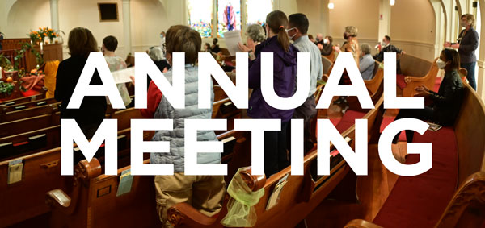

FIRST CONGREGATIONAL ANNUAL MEETING; Sunday, January 19, 2025 following the worship service with a potluck meal.

First Congregational United Church of Christ Non-Profit Org.
PO Box 111 U.S. Postage Paid
Watertown, SD 57201 Watertown, SD
THE MESSENGER, January 2025 Permit # 499
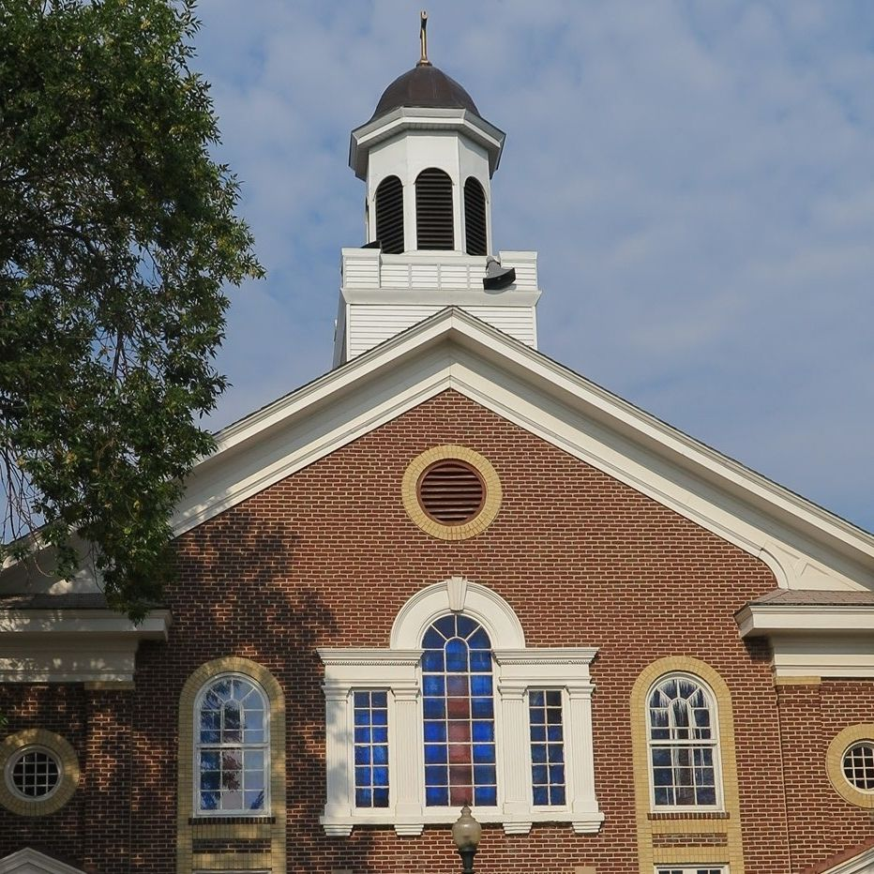

Come Worship with
Pastor Dustin Bartlett
10:00 am Sunday
Everyone is always welcome
If you can not make it to the Sunday service, you
can follow us at; http://www.uccwatertown.com.

.



Sunday morning coffee,

MEALS on WHEELS; January 6th through January 10, 2025
Coffee upstairs before and downstairs after Sunday morning worship
Sunday, January 19, UCC Annual Meeting (tentatively set) following the worship service with a potluck

 | January 2025
Sun | Mon | Tue | Wed | Thu | Fri | Sat
 |  |  | 1 | 2 | 3  Steve Zemlicka | 4  Jeff Wirkus
5  Communion Sunday | 6  Meals On | 7  Wheels ►► | 8  ►►►► | 9  Chris Negaard  ►►►► | 10  ►►►► | 11  Brenda Foster
12  Bible Study 3PM  Glenn Robel | 13 | 14 | 15  Cyndy Voight | 16  Aaron Zemlicka | 17 | 18
19  Annual Meeting with potluck meal | 20  Melissa Pond | 21 | 22 | 23 | 24 | 25
26  Bible Study 3PM | 27 | 28  Mallory Pond | 29 | 30  Pat Kitterman  Lu Walford | 31

